- SAI CHARAN
2403A52L08
BATCH-50
Lab ASS-7.5
Task 1: (Mutable Default Argument — Function Bug)
# Bug: Mutable default argument
def items—I]):
items.append(item) return items print(add_item(l)) print(add_item(2))
Fixed code:
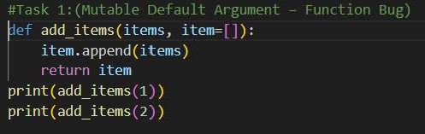
Output:
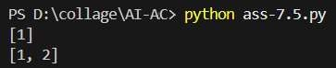
Task 2: 2 (Floating-Point Precision Error) # Bug: Floating point precision issue def return (0.1 + 0.2) 0.3 print(check_sum())
Fixed code:
#Task 2: (Floating-point precision Error) def check_sum() :
return 0.1 + I.e print(check sum())
Output:
PS D: python ass-7.5.py
False
PS D:\c011age\AI-AC> python ass-7.5.py True
Task 3: (Recursion Error — Missing Base Case)
# Bug: No base case
def countdown(n):
print(n) return countdown(n-l) countdown(5) Fixed code:
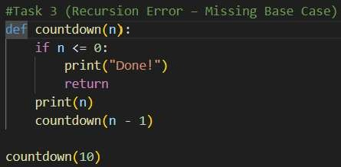
Output:
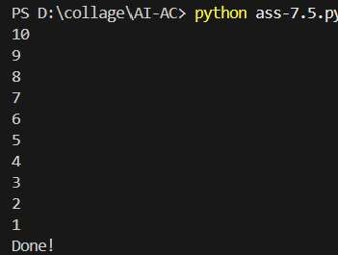
Task 4: (Dictionary Key Error) # Bug: Accessing non-existing key def get_value():
data = 1, "b": 2} return print(get_value())
Fixed code:
#Task 4 (Dictionary Key Error) def get_value( ) : data 2) eeturö data None) print( ) )
Output:
PS D:\collage\AI-AC> python ass-7.5.py None
Task 5: (Infinite Loop — Wrong Condition)
# Bug: Infinite loop def loop_example():
while i < 5:
print(i)
Fixed code:
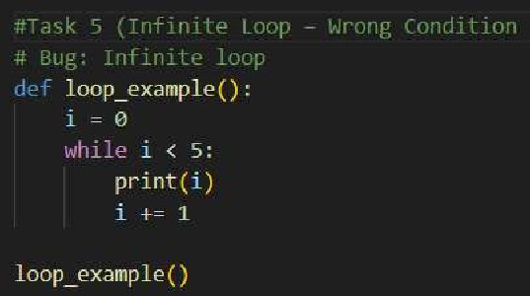
Output:
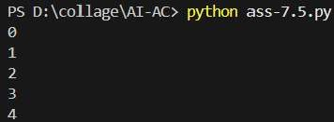
Task 6: (Unpacking Error— Wrong Variables)
# Bug: Wrong unpacking
Fixed code:
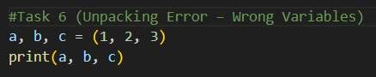
Output:
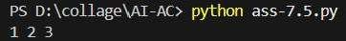
Task 7: (Mixed Indentation — Tabs vs Spaces) # Bug: Mixed indentation def func():

y: 10
return x+y Fixed code:
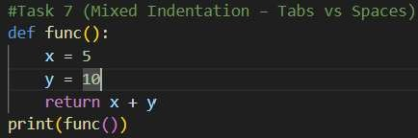
Output:
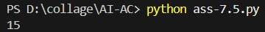
Task 8: (Import Error— Wrong Module Usage)
# Bug: Wrong import import maths print(maths. sqrt(16)) Fixed code:
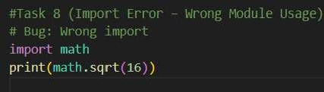
Output:
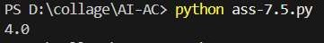
Task 9: (Unreachable Code — Return Inside Loop)
# Bug: Early return inside loop def tota umbers):
for n in numbers:
return n
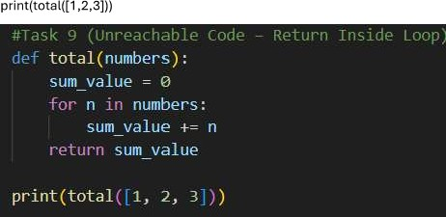
Output:
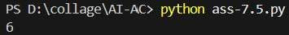PS D:
Task 1 0: (Name Error— Undefined Variable)
# Bug: Using undefined variable def return length width
Fixed code:
#Task 10 (Name Error - Undefined Variable)
def calculate area(length, width): return length width
# Test cases assert calculate area(5, 10) 50 assert calculate area(3, 21 assert calculate area(e, 10)
print("A11 tests passed successfully! " )
Output:
PS D: python ass-7.5.py All tests passed successfully!
Task 11: (Type Error — Mixing Data Types Incorrectly)
# Bug: Adding integer and string def return 5 + "10"
Fixed code:
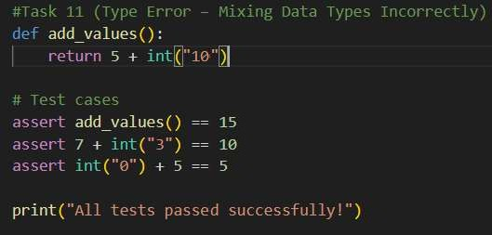
Output:
PS D:\c011age\AI-AC> python ass-7.5.py
All tests assed successfull !
Task 12: (Type Error — String + List Concatenation)
# Bug: Adding string and list def combine():
return "'Numbers: " + [1 , 2, 3] print(combine())
Fixed code:
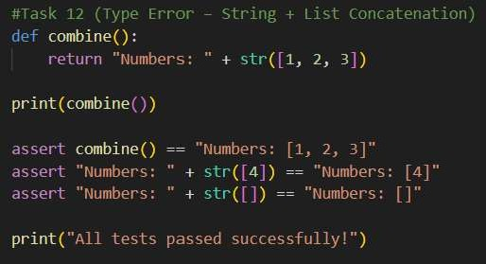
Output:
PS D: python ass-7.5.py
Nunbers: [1, 2, 3]
All tests assed successfull !
Task 13: (Type Error— Multiplying String by Float)
# Bug: Multiplying string by float def repeat_text():
return "Hello" 2.5
Fixed code:
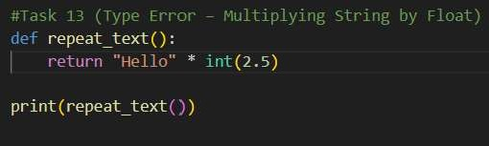
Output:
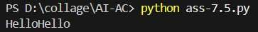
Task 14: (Type Error— Adding None to Integer)
# Bug: Adding None and integer def compute():
value = None return value + 10 print(compute())
Fixed code:
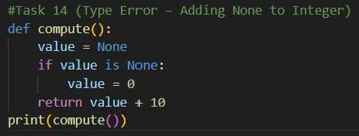
Output:
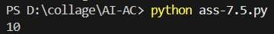
Task 15: (Type Error— Input Treated as String Instead of Number)
# Bug: Input remains string def sum_two—numbers():
- inputC'Enter first number:
- = input("Enter second number:
return a + b numbers()) Fixed code:
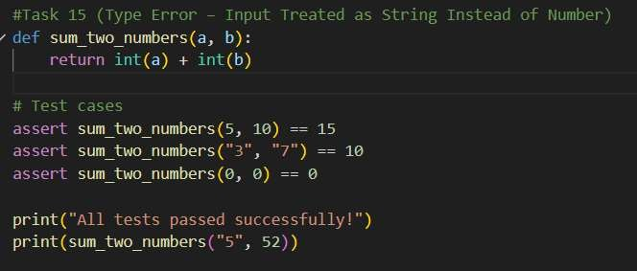
Output:
PS |  |  |  |  |  | python ass-7.5.py
All tests  57 |  |  | passed |  |  | successfully!

